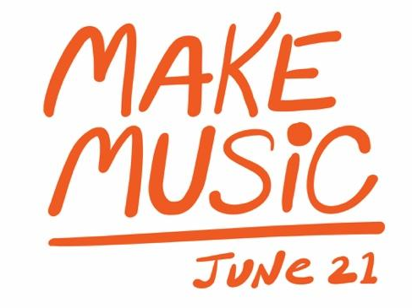

<Insert Name of Company> Celebrates Make Music Day with <Event>
<Town/community name> participates in global celebration
of making music on the longest day of the year

<CITY>, <State> (<Date>) — <Name of Company> joins the Make Music Day <If there is a local Make Music City event in your area, mention it here as well> celebration with a <Insert brief event description> on Saturday, June 21, 2025. Make Music Day is a one-day event where free, live musical performances, opportunities to make music and other musical events take place around the world on the longest day of the year. Musical festivities in <city/town> are part of a global celebration of music making in over 2,000 cities inspired by France’s Fête de la Musique.

<Name of Company> invites everyone from professional musicians to people who have never picked up an instrument to join in the global music celebration by attending <event.> <Insert details about event, place, time it begins and ends, and what participants can expect to see/hear/do.>

<Insert “QUOTE” from company spokesperson about Company’s participation in Make Music Day and how making music positively affects community.>

Music has been shown to strengthen social connectivity, reduce stress, lower blood pressure, stimulate memory, and is integral to a well-rounded, enjoyable life. By participating in Make Music Day, <Company> and <Town/Community> encourage every form of music making.

National Association of Music Merchants (NAMM) members and partners from coast to coast, including <Company>, will join in their communities’ celebrations of Make Music Day. June 21 is the perfect day to check out a local music store for some gear or to come together and play – whether it’s for the first time or the thousandth.

<Company contact information>

About <Company>

About Make Music Day:
Held annually on June 21 to coincide with the Summer Solstice, Make Music Day is part of the international Fête de la Musique taking place in more than 2,000 cities around the world. The day-long, musical free-for-all celebrates music in all its forms, encouraging people to band together and play in free public concerts. This year, over 150 U.S. cities and the entire states of Connecticut, Hawaii, Missouri, North Carolina, Texas, Vermont, and Wisconsin are organizing Make Music celebrations, encompassing thousands of music-making opportunities nationwide. Make Music Day is presented by The NAMM Foundation and coordinated by the nonprofit Make Music Alliance. For more information, please visit www.makemusicday.org.

###

